***JAVA END***

***SEM PROJECT REPORT***

***19AIE105***

*GROUP 5*

**ACKNOWLEDGEMENT**

We would like to express our gratitude to

our professor Dr. CHANDRALEKHA mam who gave us this golden opportunity to

do the project on the topic “ **DIGITAL WATCH USING JAVA “.**

We would like to extend our gratitude to the AIE department of Amrita Vishwa Vidhyapeetham, Chennai who assigned this project to us and helped us to improve our knowledge.

ABSTRACT

* Our project has been built based on the idea of software based **“ DIGITAL WATCH ”** which includes the features like DATE, DAY, TIME, STOPWATCH, and ALARM.
* It is more like a software based basic digital wrist watch.
* Basically, a watch can be used to have a track of our time.
* Stopwatches can be used to measure the duration of an manually. These are used widely in many aspects. Sports is one the best applications of stopwatch.
* Alarm can be used to make ourselves alert or aware about something at some specified time. We are using alarms in our day to day life for many purposes. This makes our works more easier by making us not to remember about that event.

SOFTWARE USED

* **Visual Studio Code with built-in JDK.** 
* **Eclipse IDE.** 
* **Referred sources : -**

* + - * + GIT HUB
        + STACK OVERFLOW
        + TENSOR FLOW

SOURCE CODE

The source code and project description has been uploaded in GITHUB and link of the repository is given below.

[**https://github.com/SarrveshNagarajan/SIMPLE-JAVA-WATCH-.git**](https://github.com/SarrveshNagarajan/SIMPLE-JAVA-WATCH-.git)

OUTPUT

* The screenshots of the output is attached below.

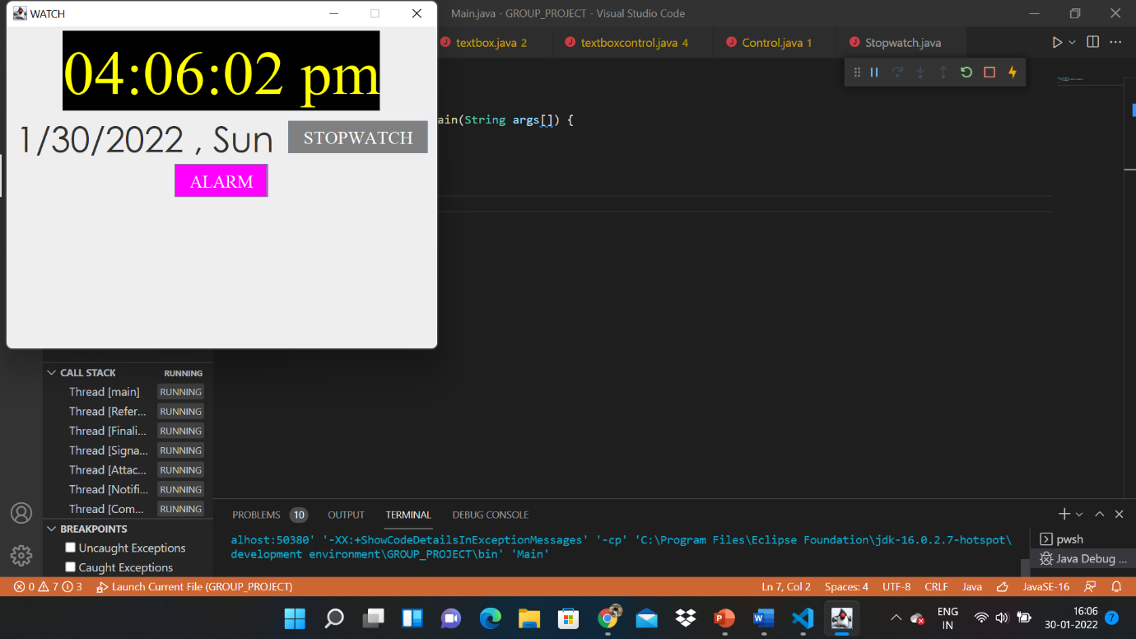

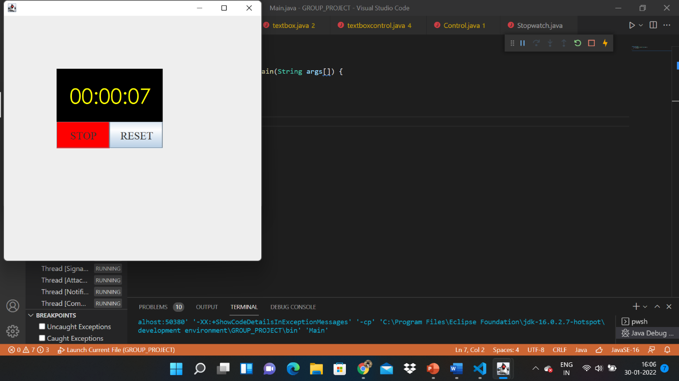

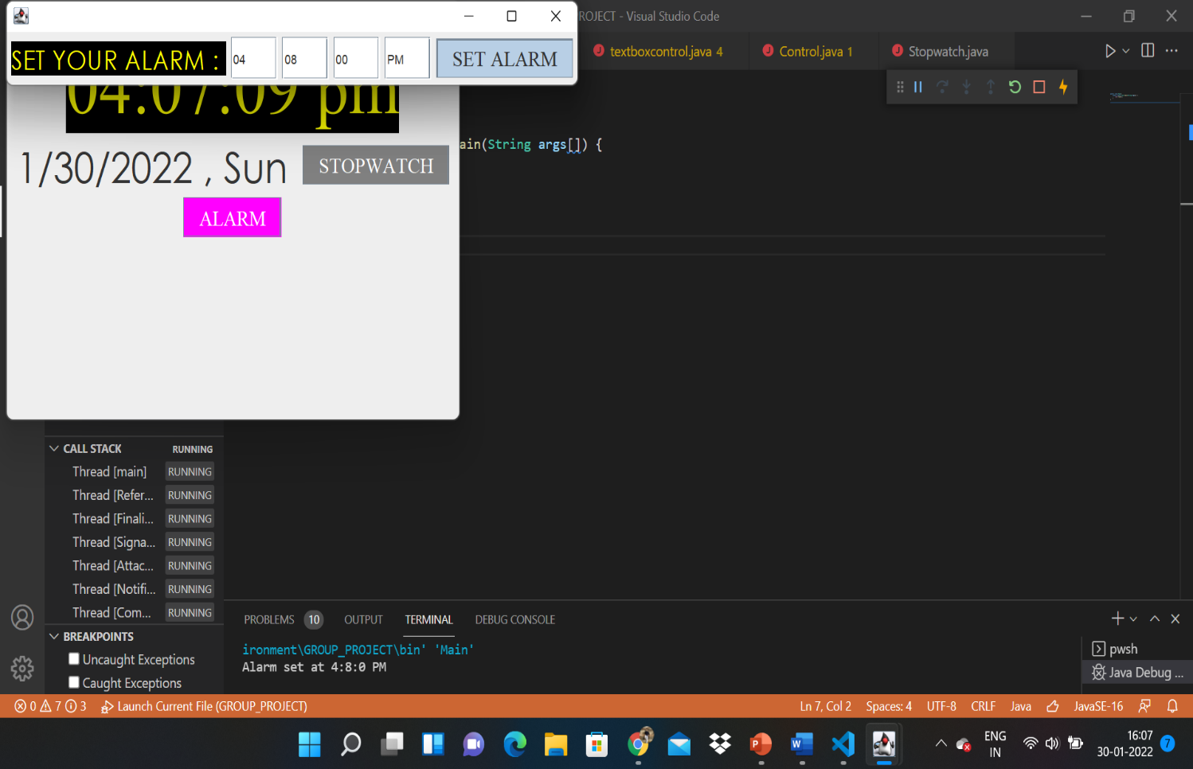

A TEAMWORK OF

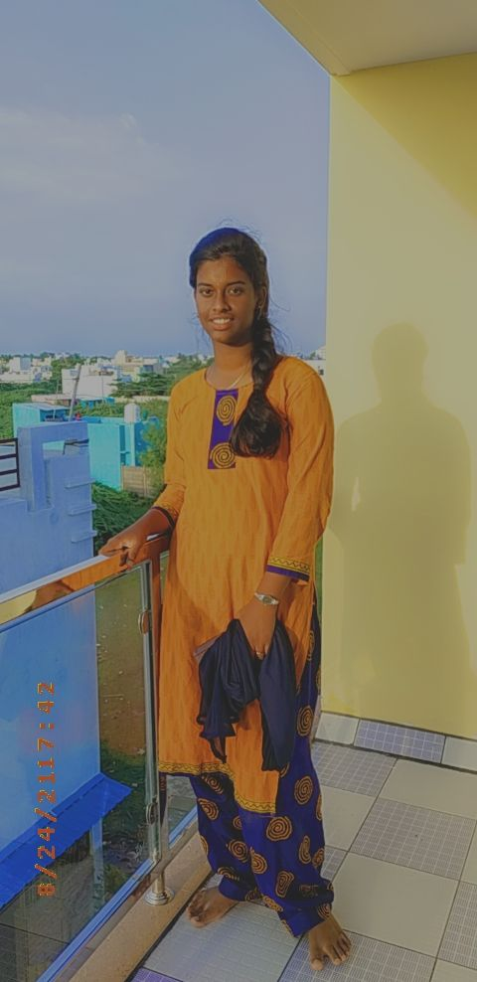 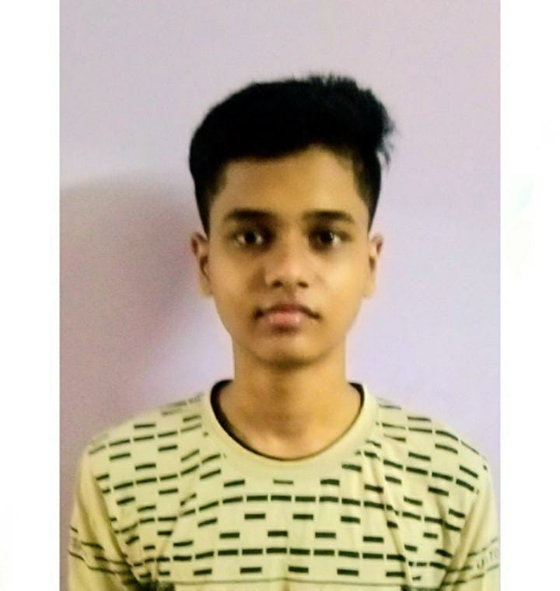 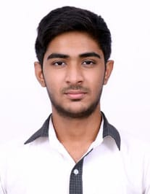

***POORANI PRANAV RAJ SARRVESH***

***AYSWARIYA***

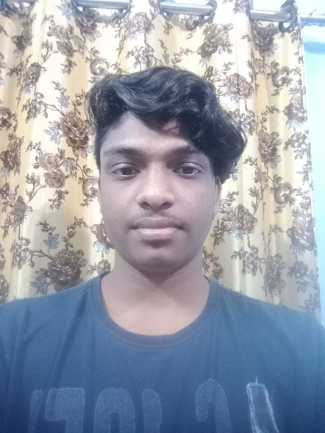 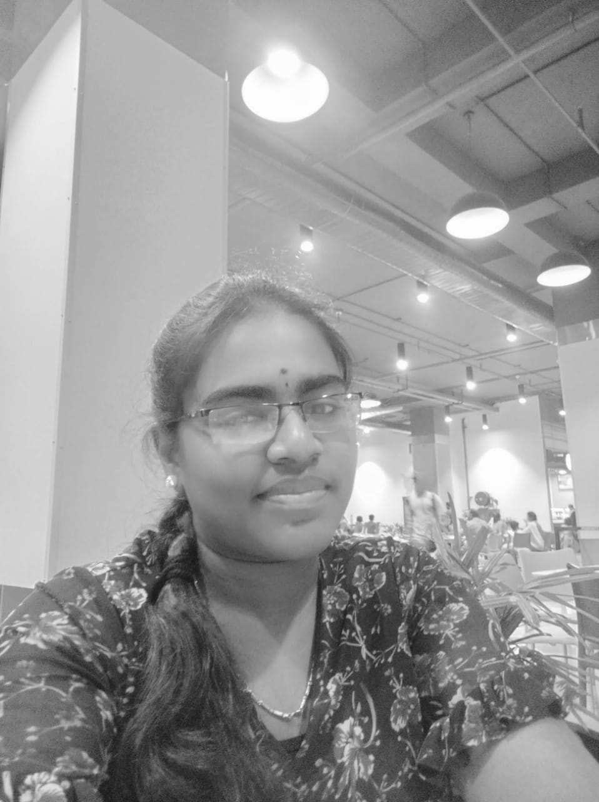

***SIDESH SUNDAR*** ***YAGNITHA***